**CICS Screen Designing**

**Go to LL(SDF 2 option)**

**Tweaking settings**

8 SPECIFY LIBRARIES

Preferebly keep 1st library as the working library

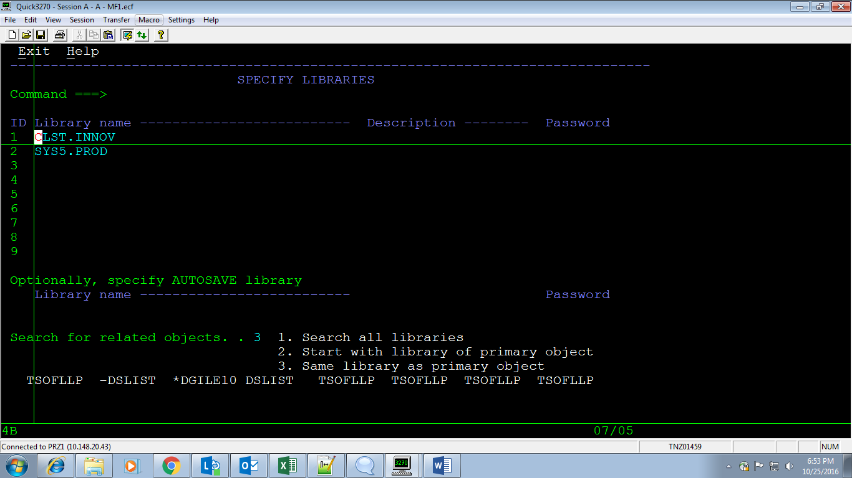

1. **PANEL EDITOR**

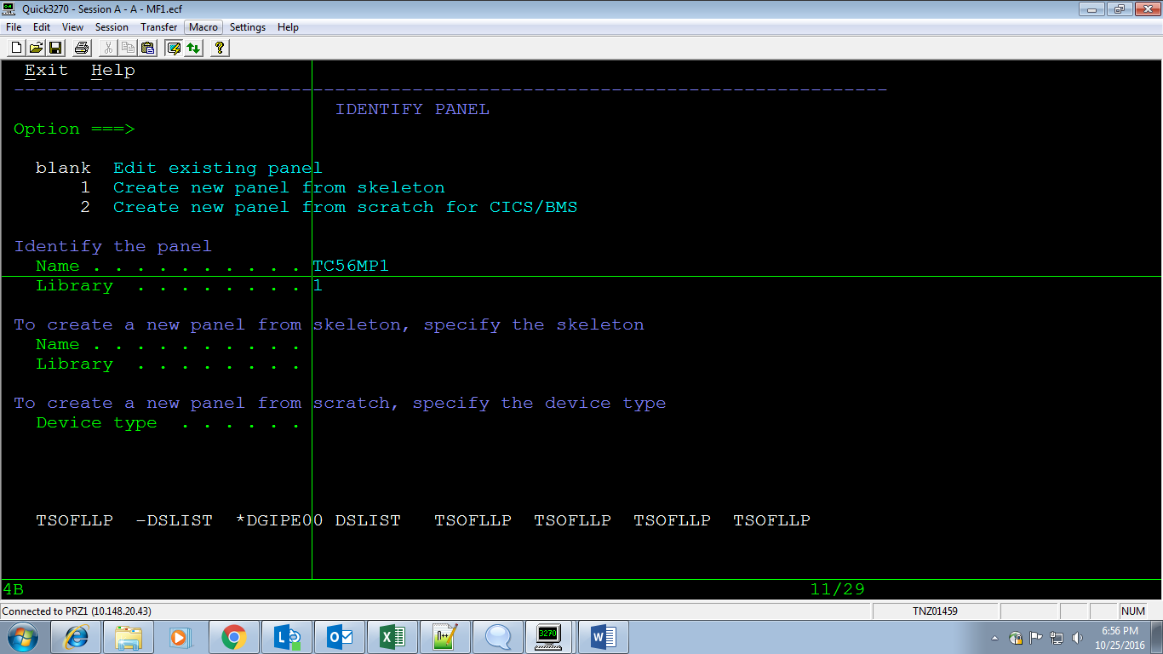

**2 PANEL GROUP EDITOR**

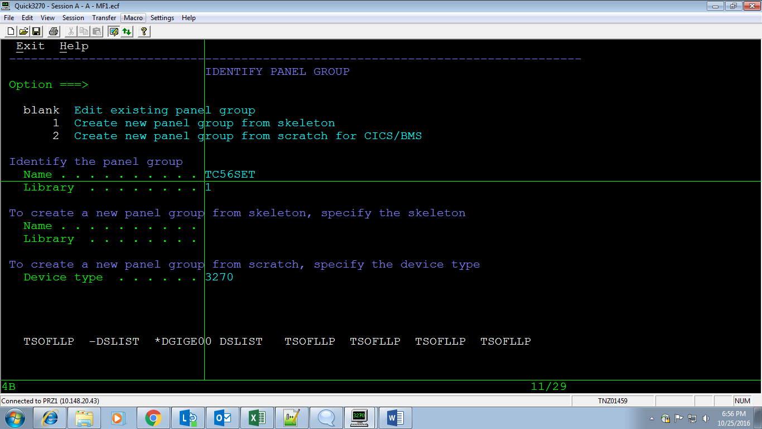

**5 CONTROL TABLE EDITOR**

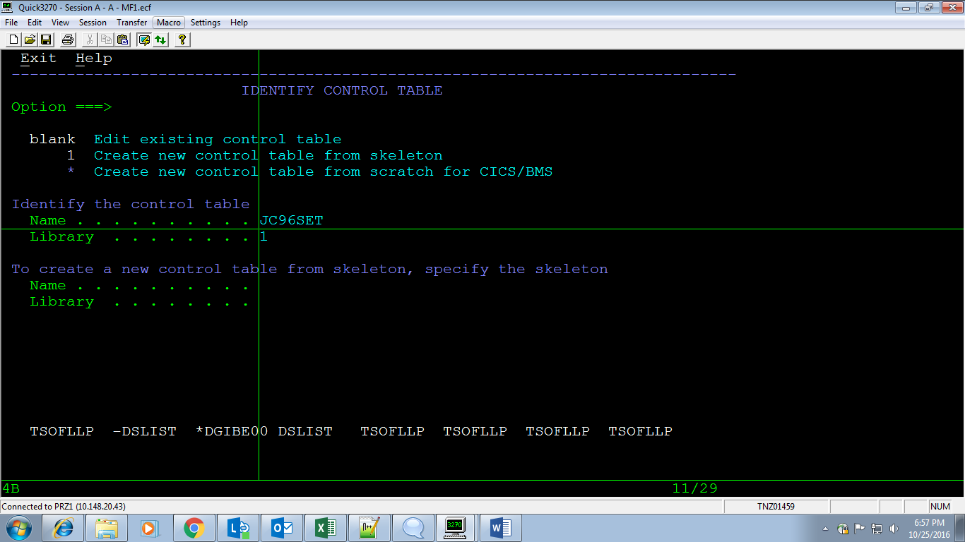

**10 PROFILE**

**2 DEFAULTS**

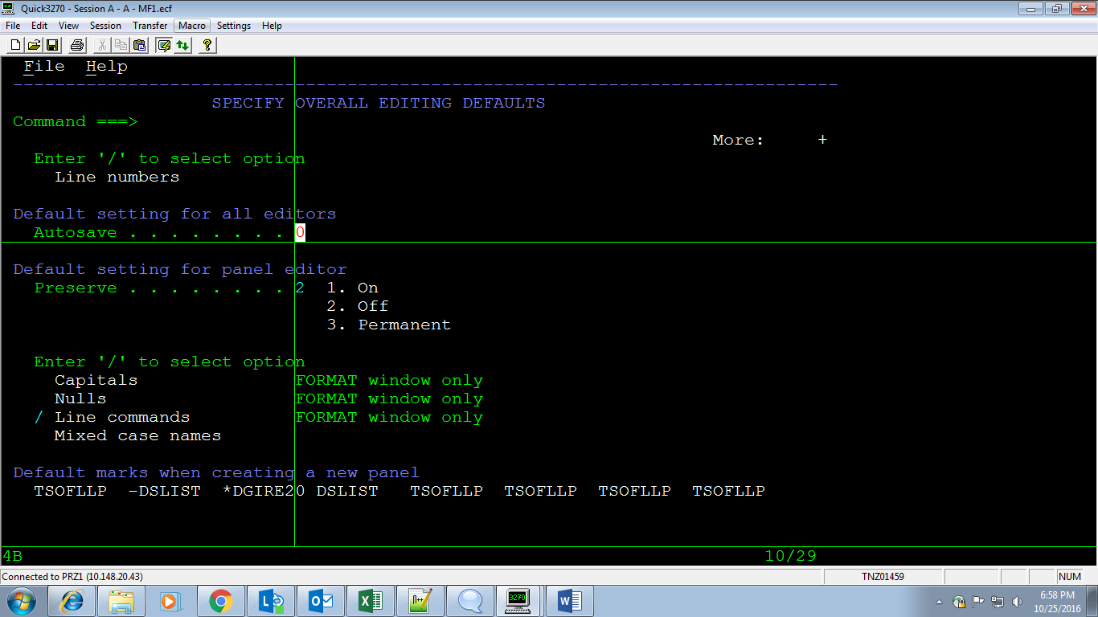

**7 LIST OBJECTS**

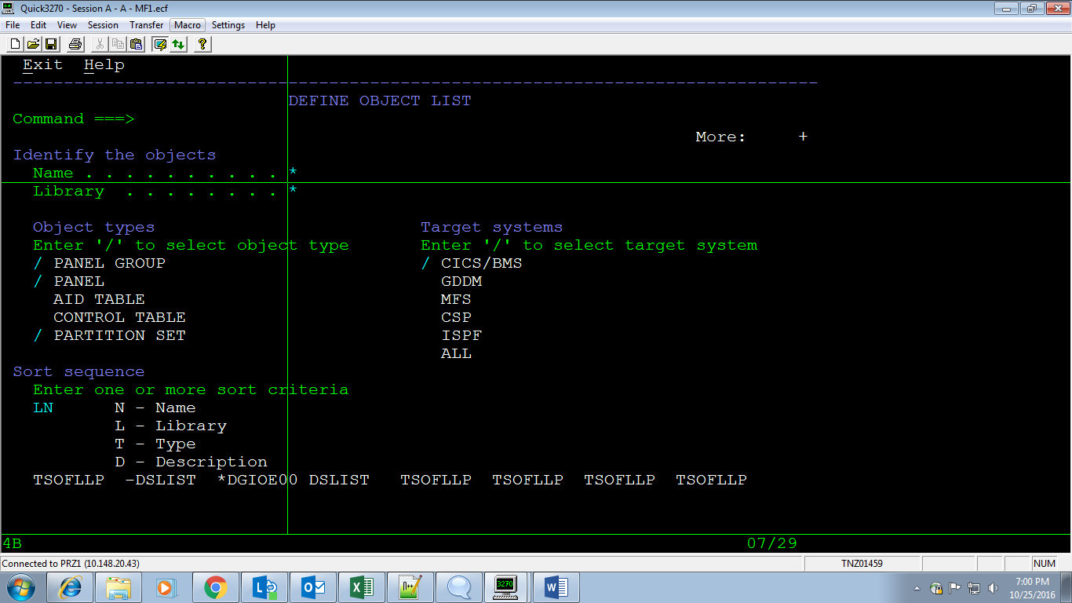

**Screen desingning**

**LL;1;**

**2 FORMAT**

